1. Launch one ec2 using Amazon Linux 2 image and add script in user data to install Apache.

* Create Instance **Apache_EC2**
* Bootstrapping with script to install **httpd** along with instance

**#!/bin/bash**

**Sudo yum -y install htttpd**

**Echo “ Hello installed using userdata” >> /var/www/html/index.html**

**Sudo systemctl start httpd**

* Launch instance
* Connect the git bash with ec2 instance by  **ssh -I Aws_key.pem ec2-user@Ipofinstance**
* Start and check the status of httpd by  **sudo yum update**

**Sudo systemctl start httpd**

**Sudo systemctl status httpd**

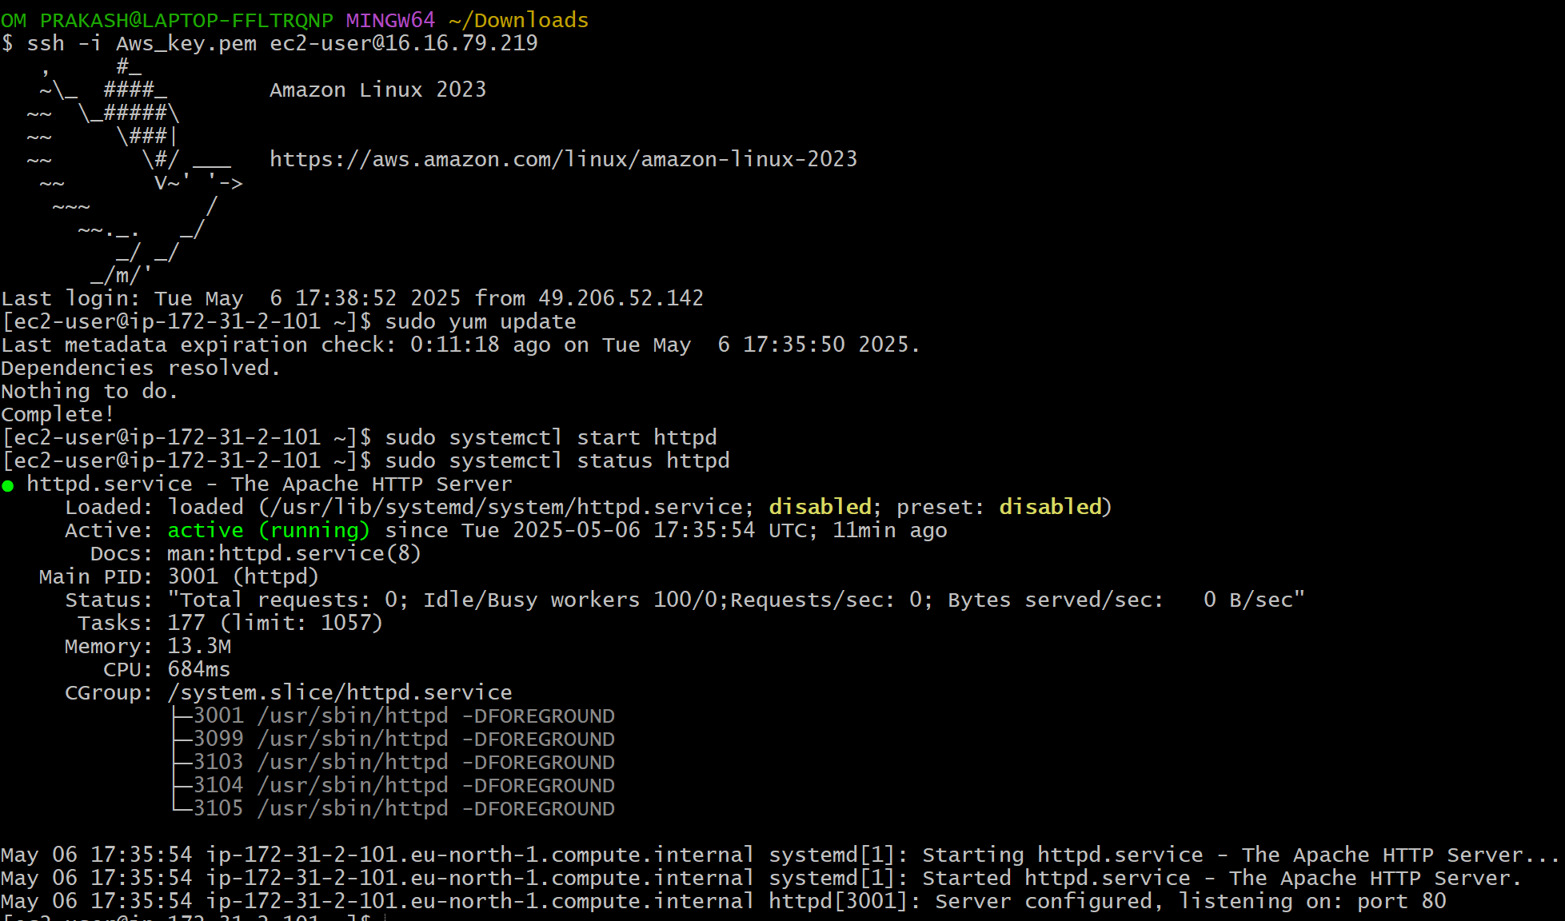

* Then check the webpage

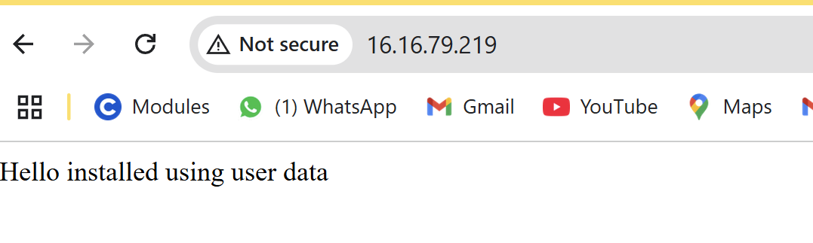

1. Launch one ec2 using Ubuntu image and add script in user data to install Nginx.

* Create Instance **nginx-ubuntu**

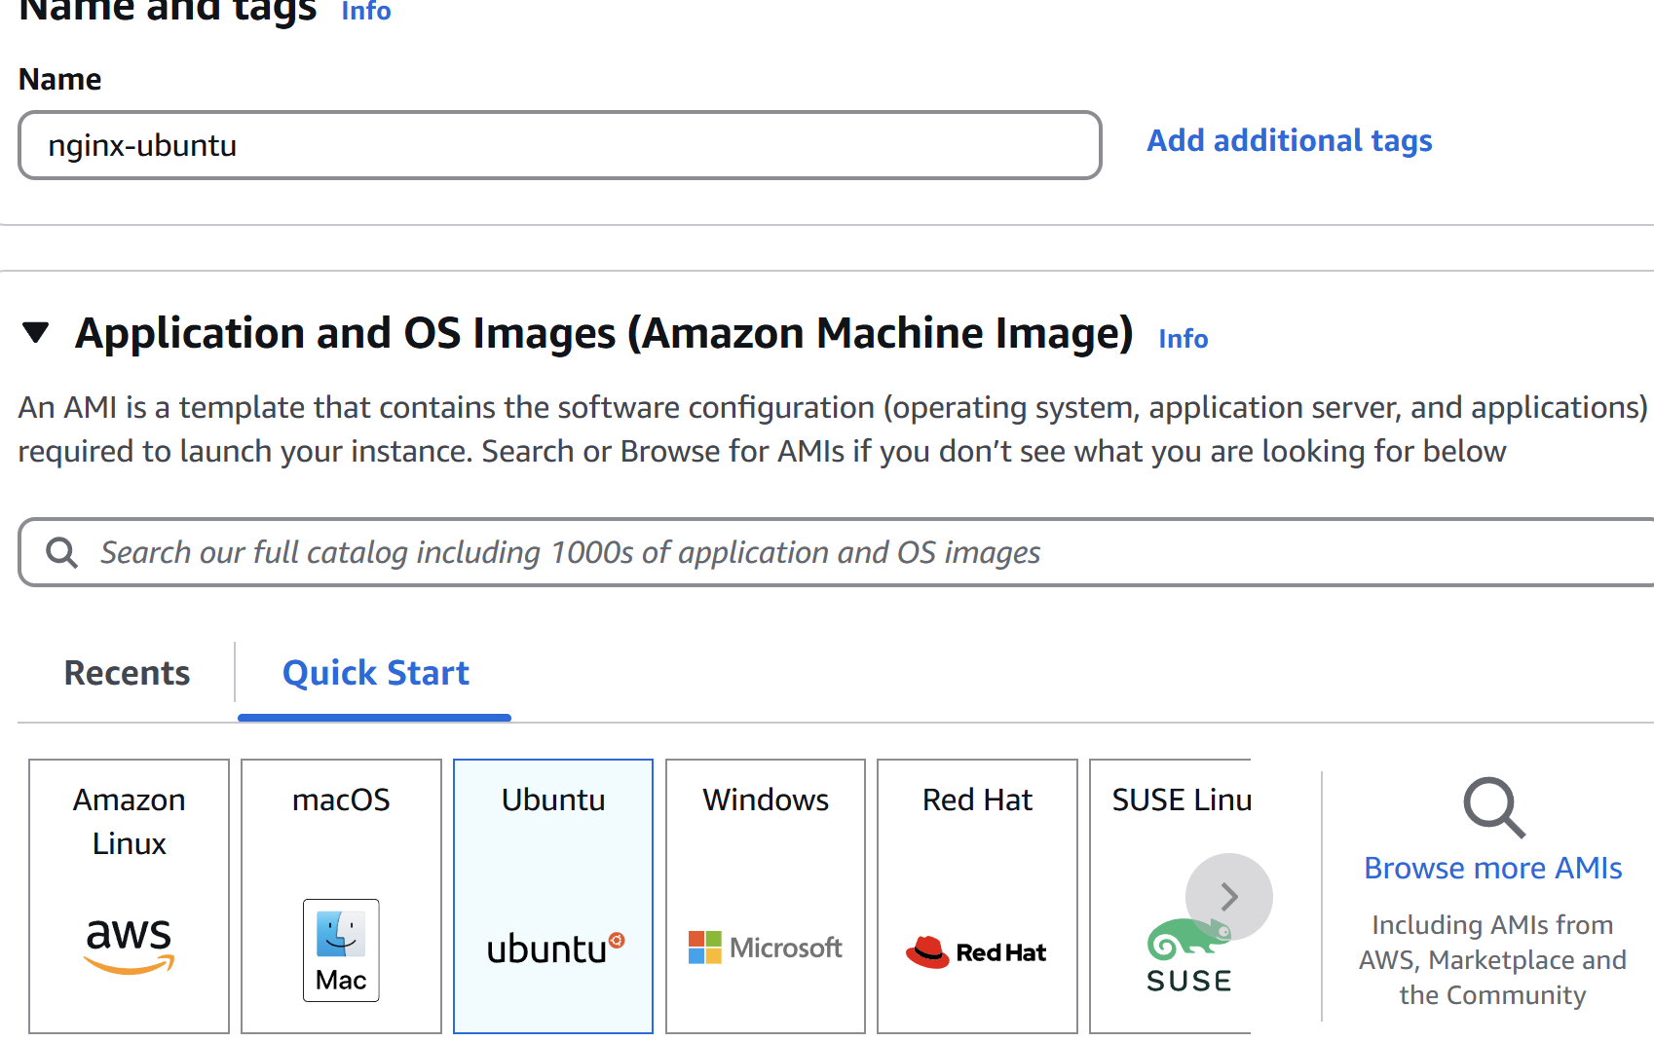

* Bootstrapping with script to install **httpd** along with instance

**#!/bin/bash**

**apt update -y**

**apt install nginx -y**

**systemctl start nginx**

**systemctl enable nginx**

* Launch instance
* Connect the git bash with ec2 instance by  **ssh -I Aws_key.pem ubuntu@Ipofinstance**

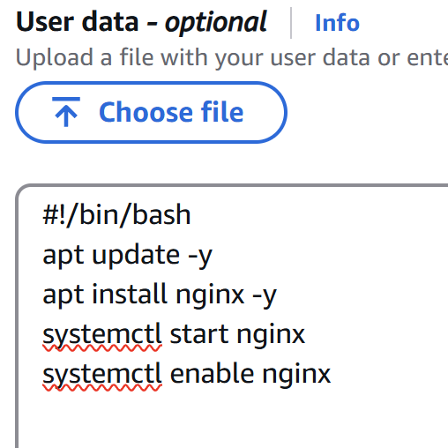

* **Sudo apt udate**
* **sudo systemctl status nginx**

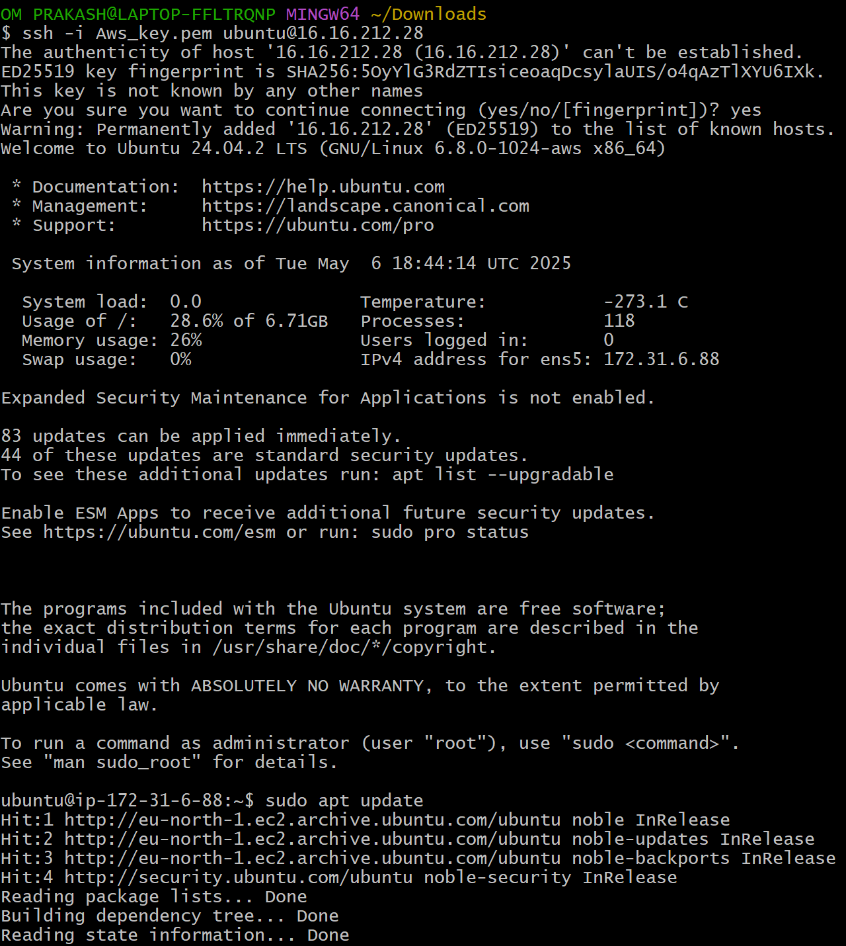

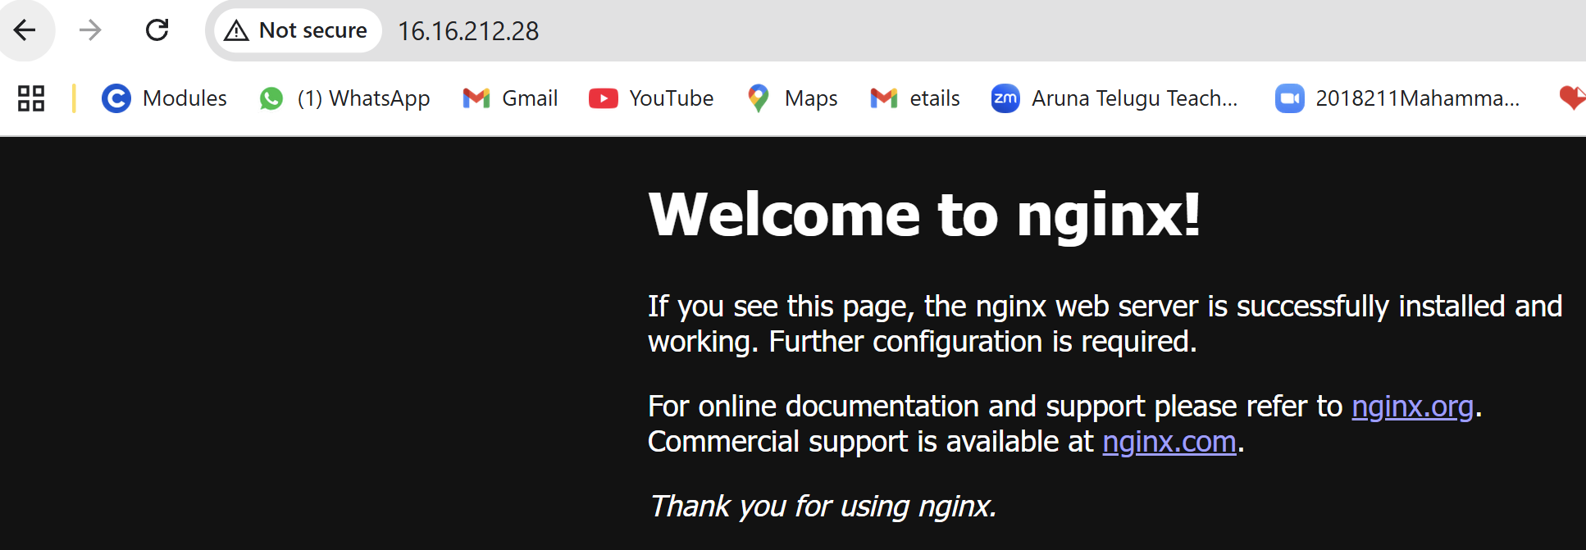

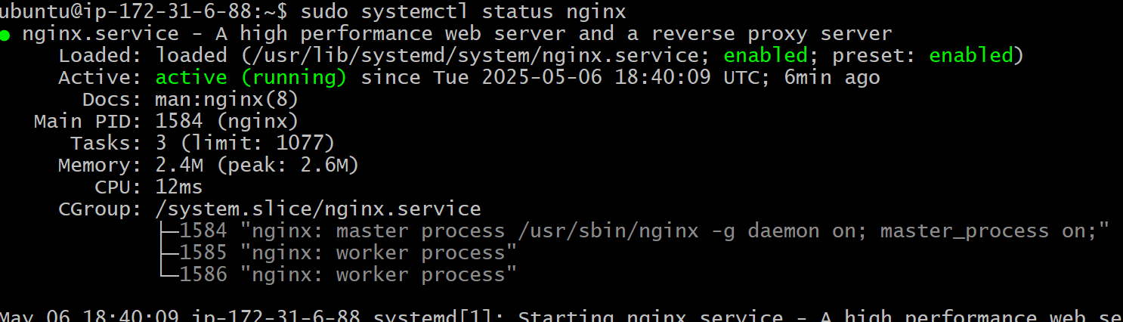

1. Launch one windows server and install tomcat in windows.

* Go to Aws console and launch one ec2 instance
* Name it as wnd-tmct
* Select **Microsoft Windows Server in AMI**
* Choose t3.micro
* Select “Create new key pair” as **wnd-tm.pem**
* Select or create a new Security Group.

Add the following Inbound Rules:

Port Protocol Purpose

3389 RDP Remote Desktop

8080 TCP Tomcat Access

80 HTTP Web Access

* Launch instance
* Then get Administrator Password:

Select the instance → Actions → Connect → Get Password.

Upload your .pem key → Click Decrypt Password.

* Download and open .rdp file → Use Administrator and the decrypted password to log in.
* Install Java (JDK):

Open Microsoft Edge inside the server.

Go to https://www.oracle.com/java/technologies/javase-downloads.html

Download and install the latest Java SE Development Kit (JDK).

Optionally, set the JAVA_HOME environment variable (via System Properties → Environment Variables).

* Install Apache Tomcat:

Go to https://tomcat.apache.org

Download the Windows Service Installer.

* During install:

Provide JDK path.

Leave port 8080 as default.

Complete installation

* Start Tomcat Service:

Go to Services → Find Apache Tomcat → Start the service.

* Open Windows Defender Firewall:

Go to Inbound Rules → New Rule:

Type: Port

Port: 8080

Allow the connection

Apply to Domain, Private, Public

Name: Tomcat 8080



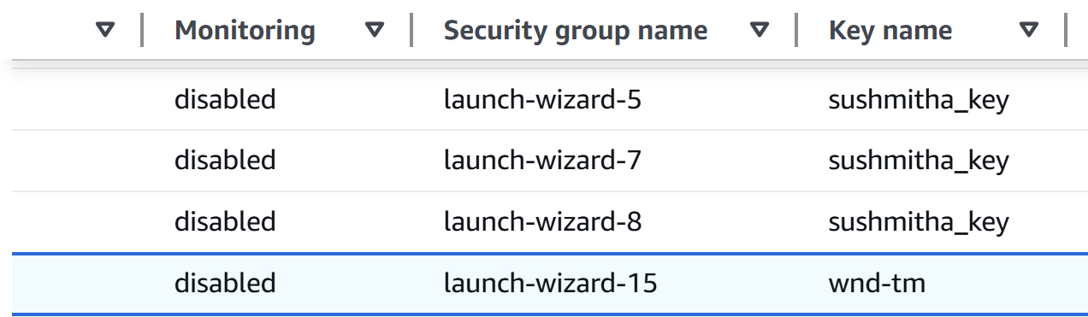

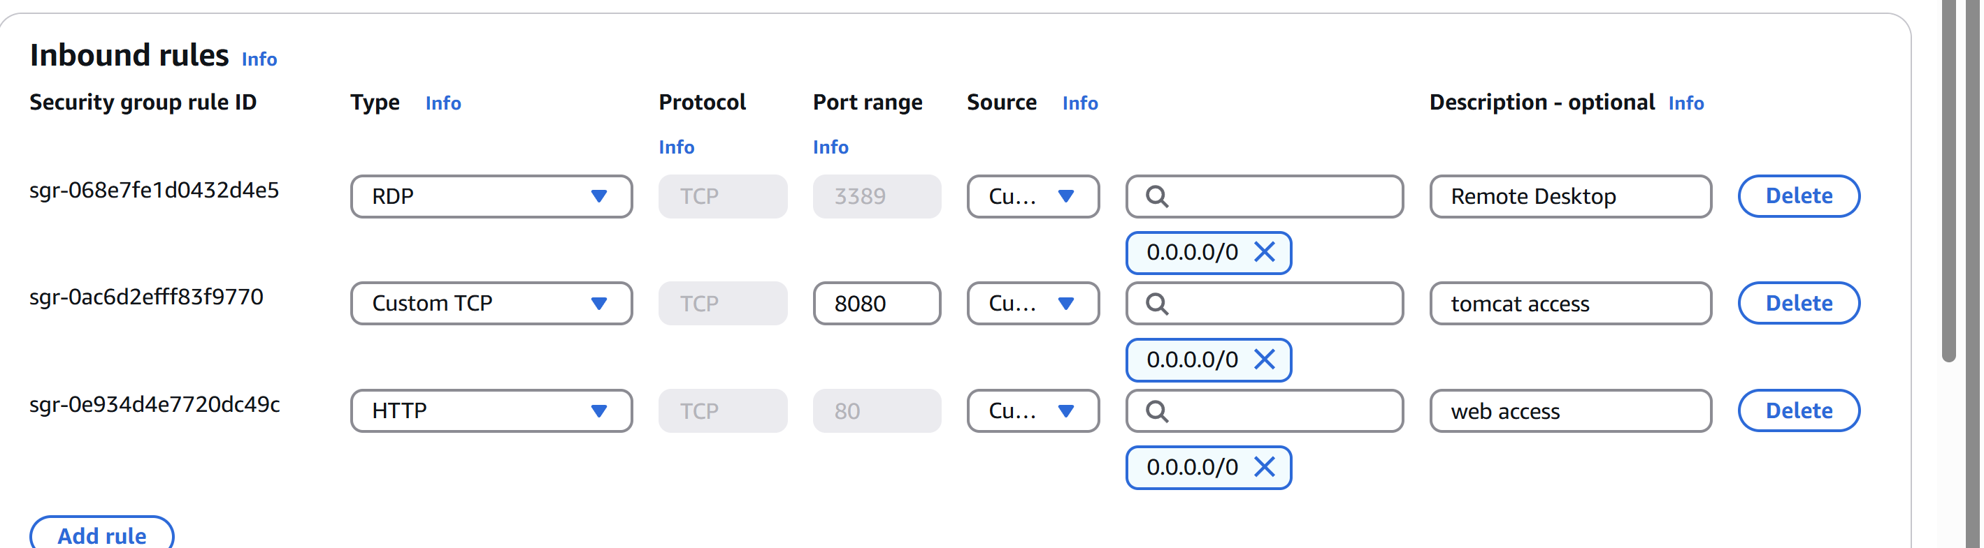

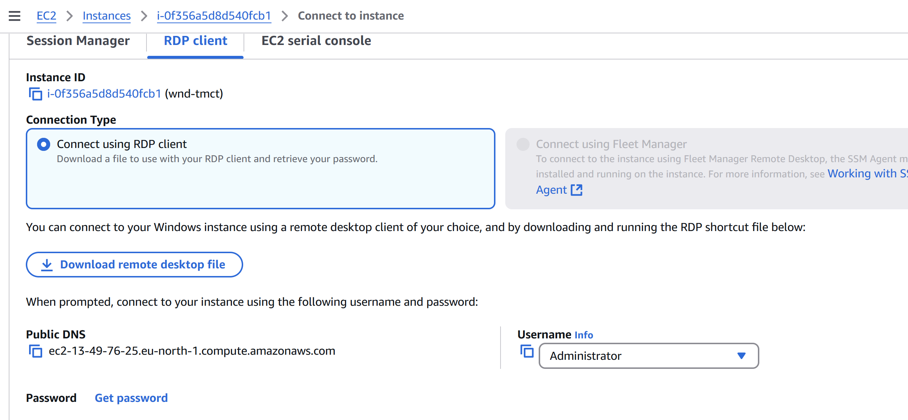

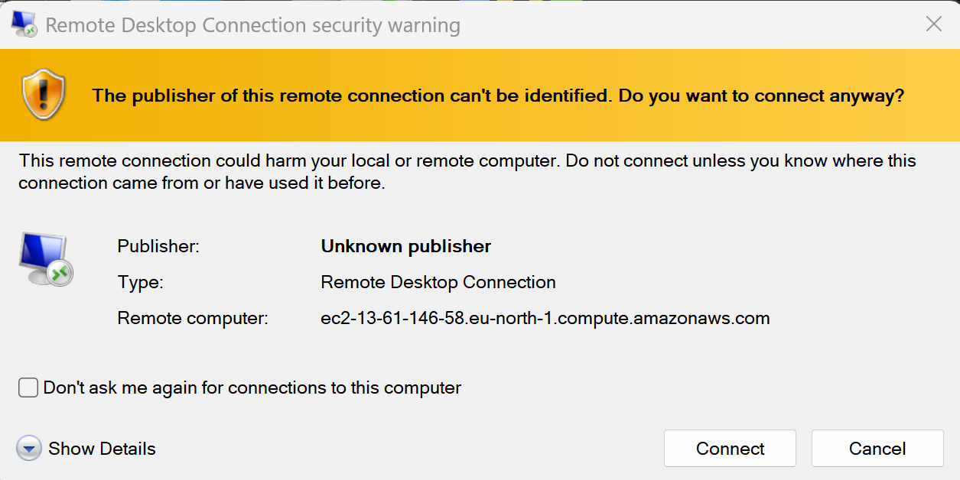

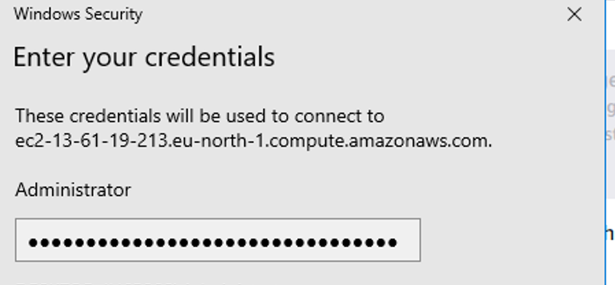



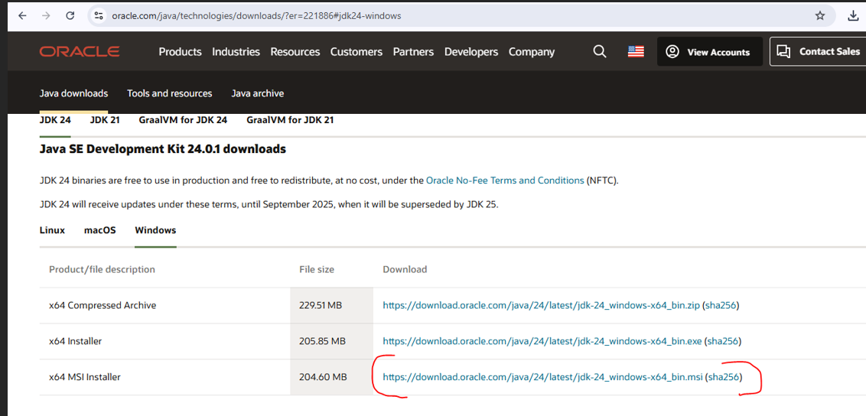

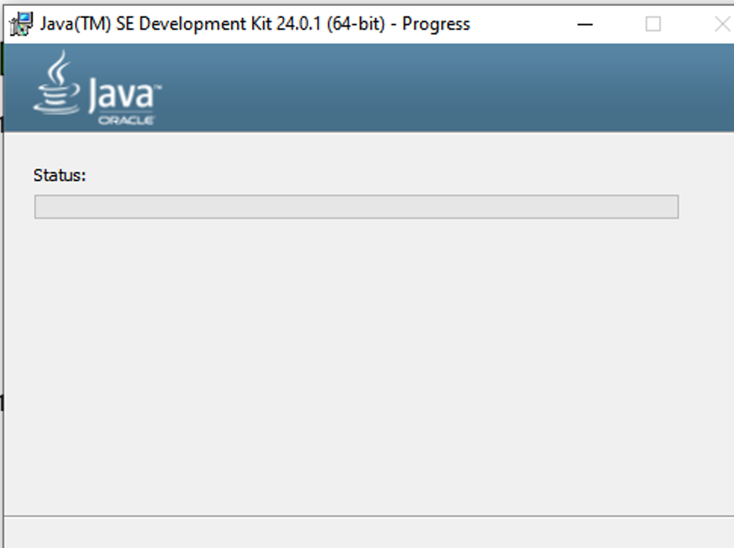

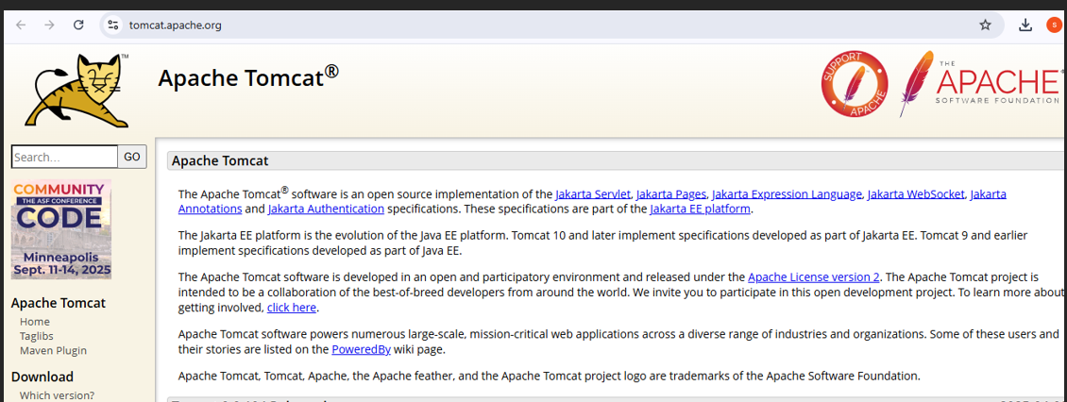

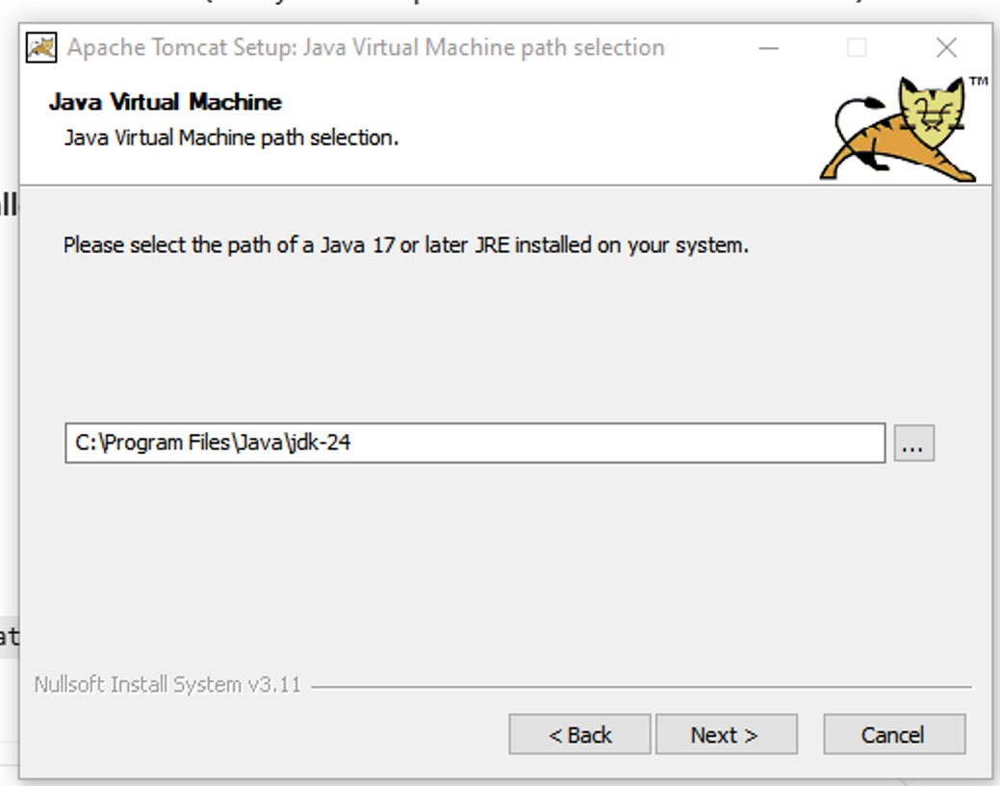

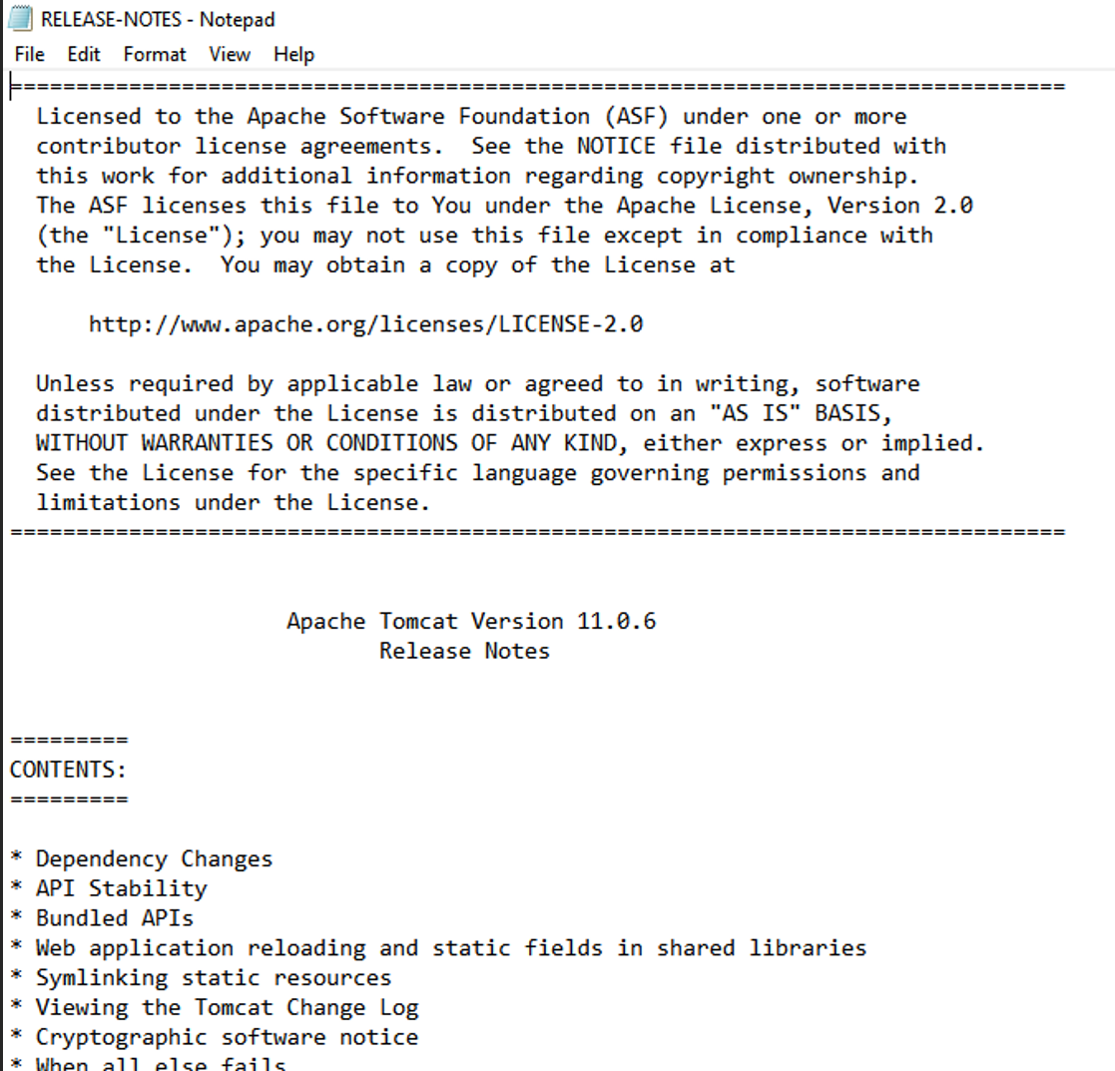

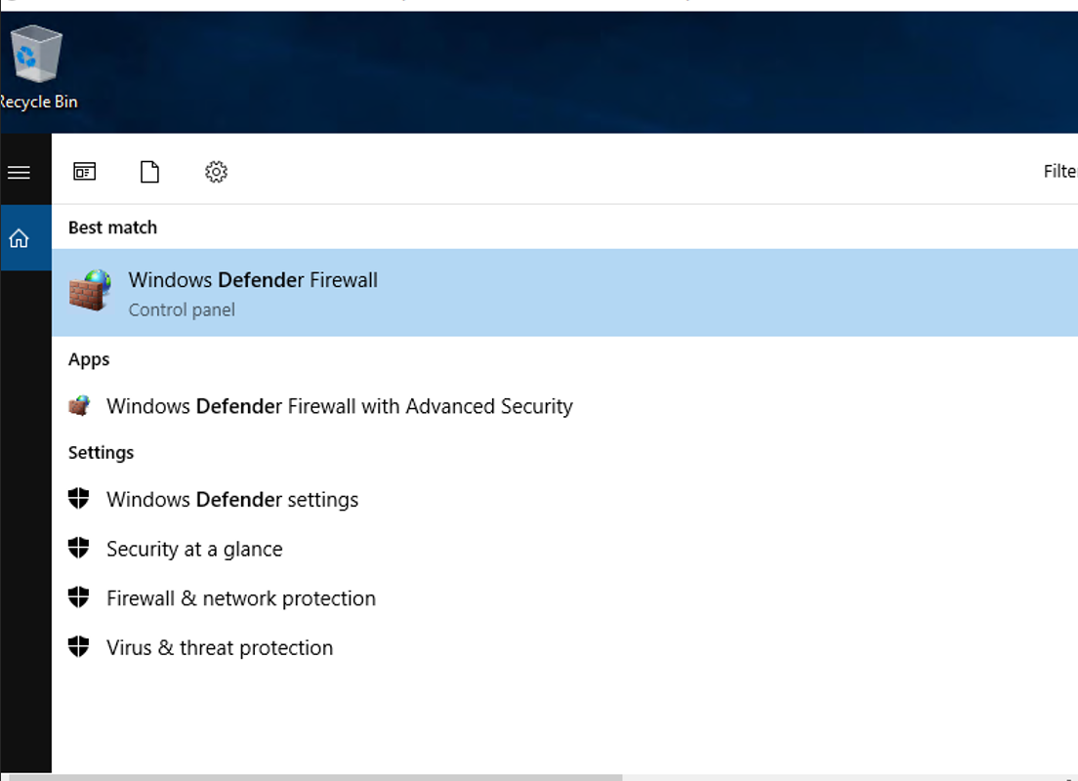

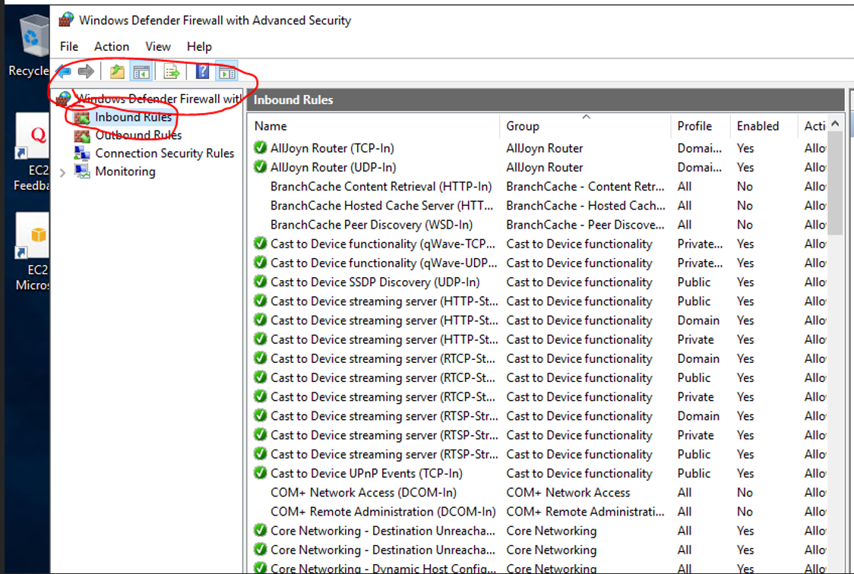

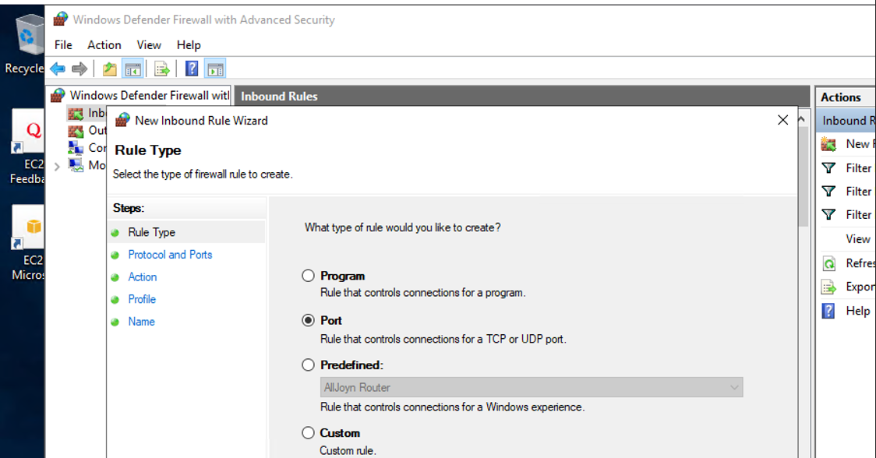

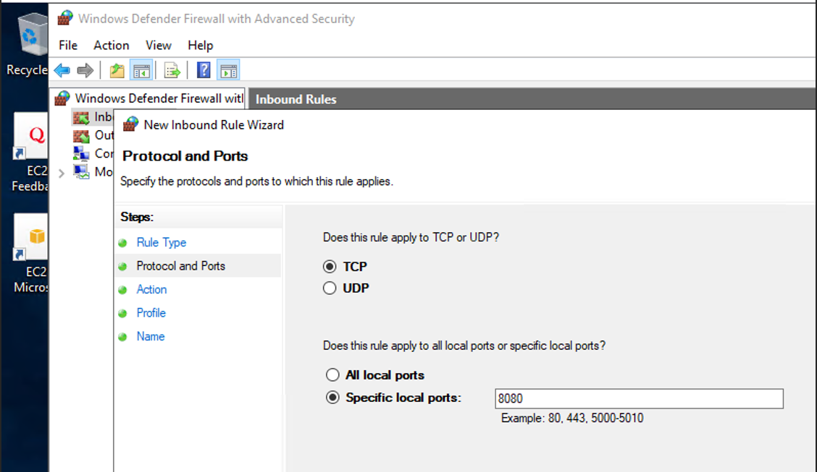

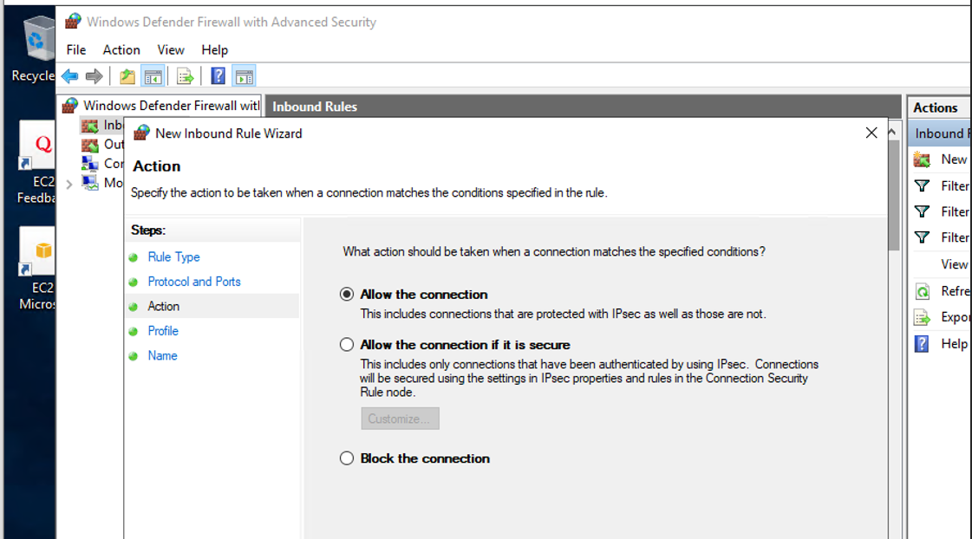

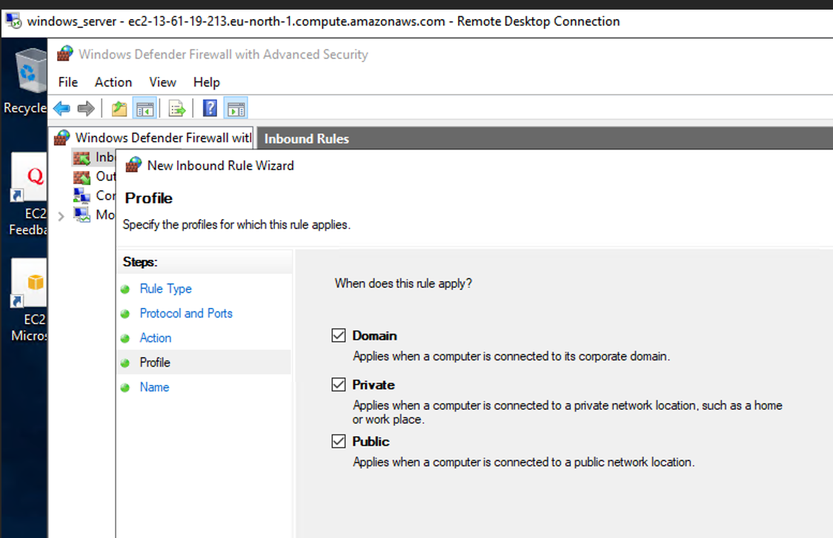

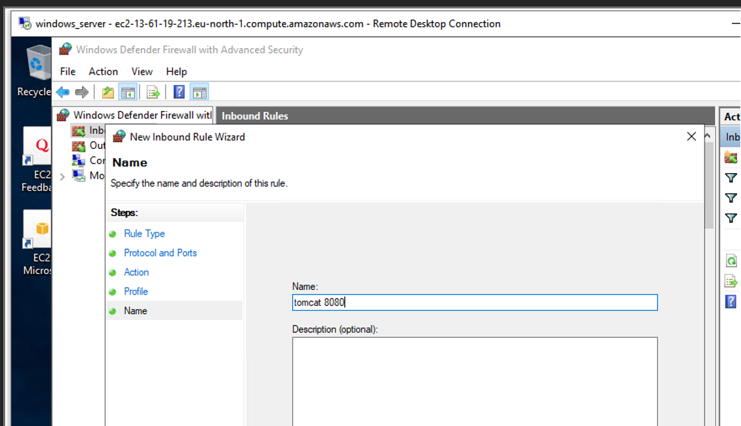

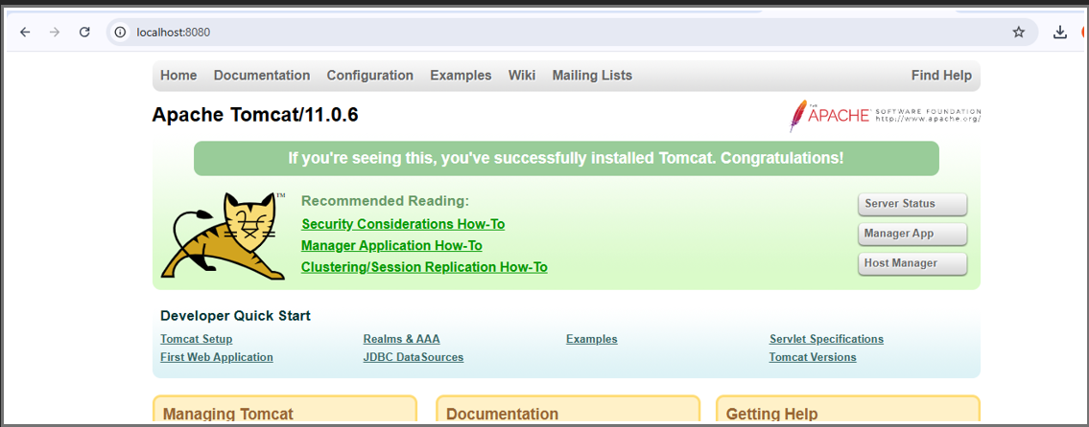

1. Take snapshot of the instane created in Task 1.

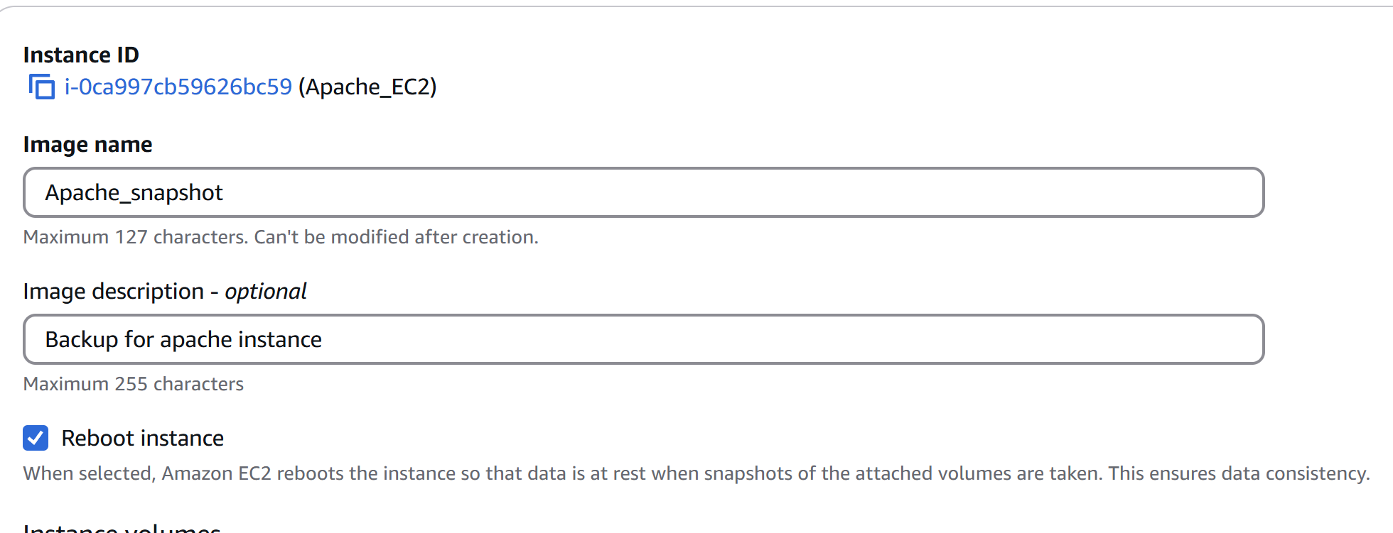



1. Assign password less authentication for ec2 created on Task 2.

* To generate Keygen

**Ssh-keygen**

* **cd /c/Users/OM\ PRAKASH/.ssh**
* **cat id_rsa.pub**  copy the generated key gen

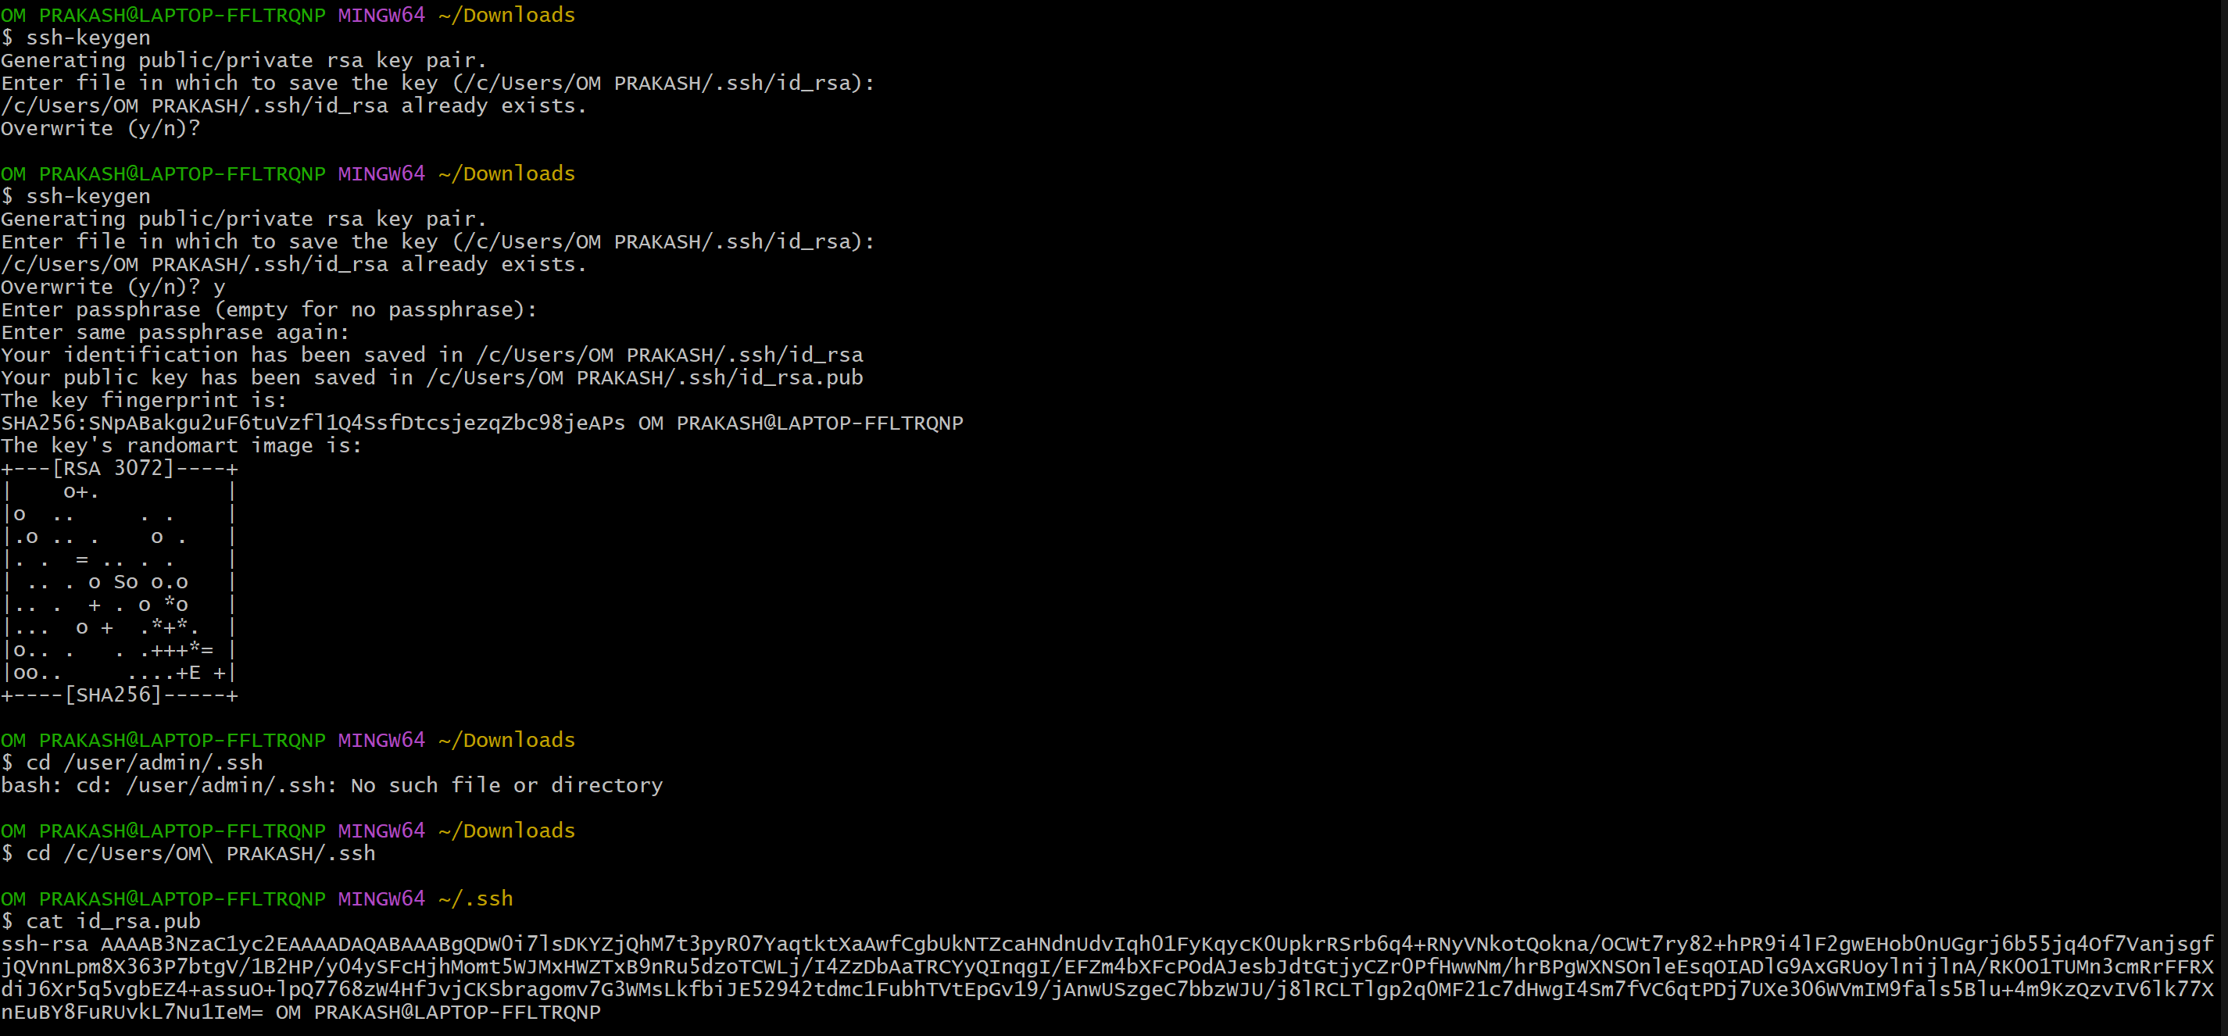

* open another tab of gitbash
* connect with the ec2 instance by **$ ssh -i "Aws_key.pem"** [**ubuntu@ec2-16-16-233-202.eu-north-1.compute.amazonaws.com**](mailto:ubuntu@ec2-16-16-233-202.eu-north-1.compute.amazonaws.com)

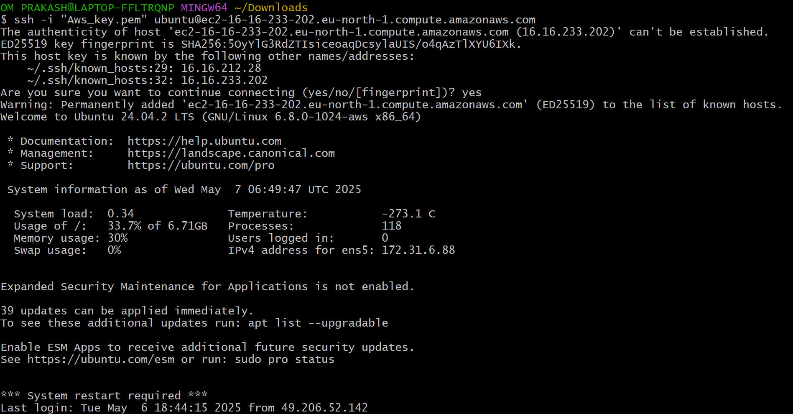

* add previously generated keygen into **authorized_keys** by **vi authorized_keys**
* chmod 700 authorized_keys
* then exit

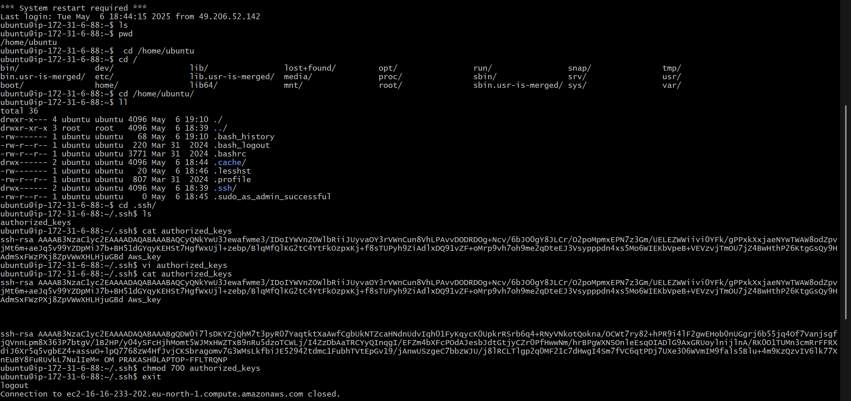

* **ssh ubuntu@16.16.233.202**

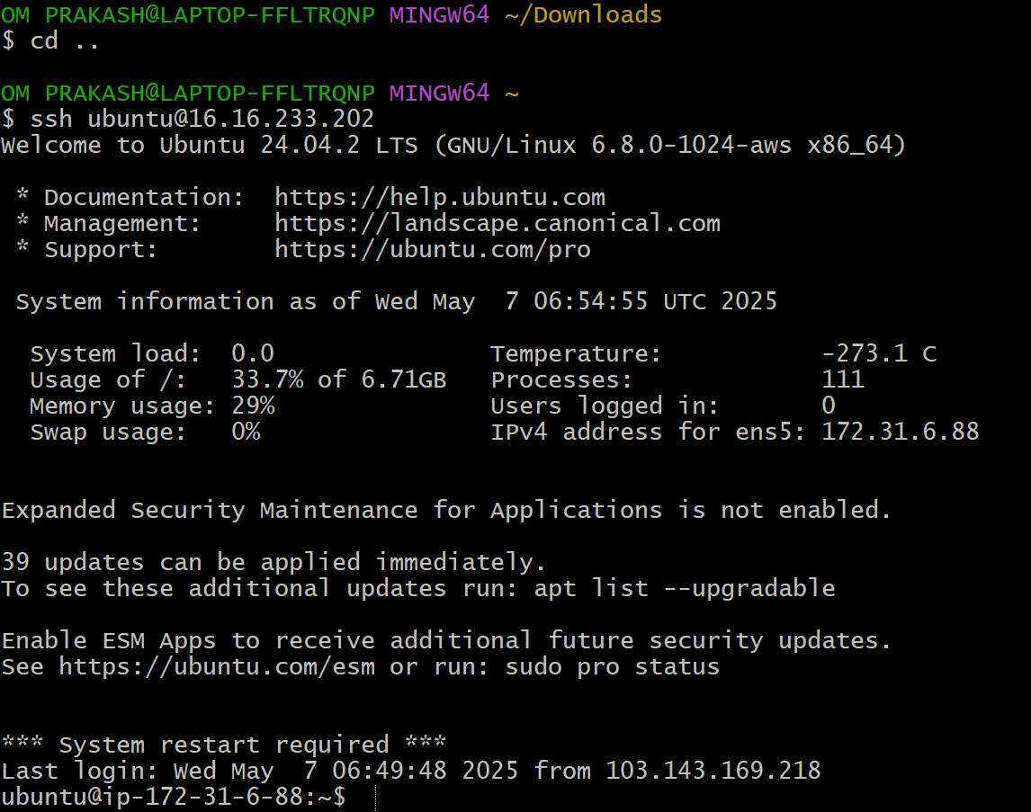

1. Launch any ec2 using spot purchasing option.

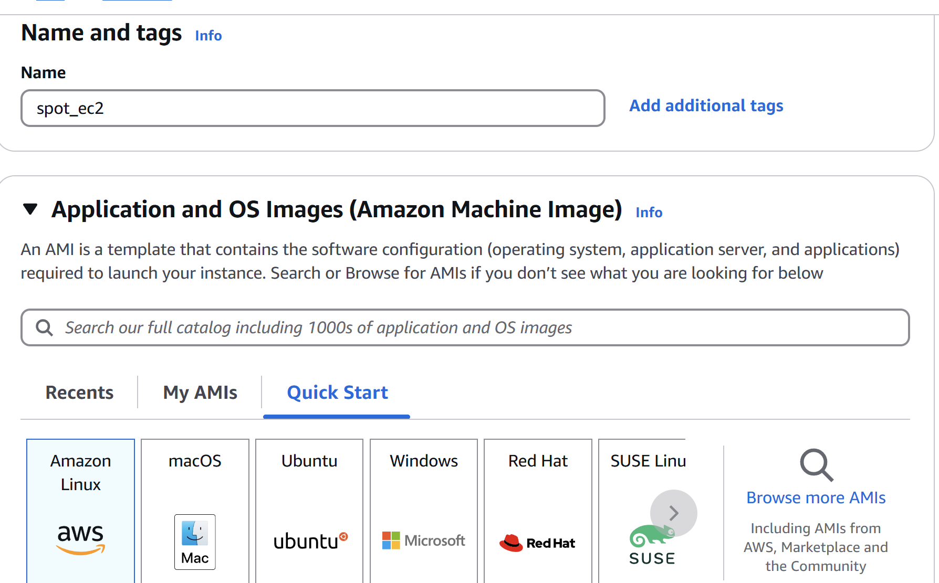

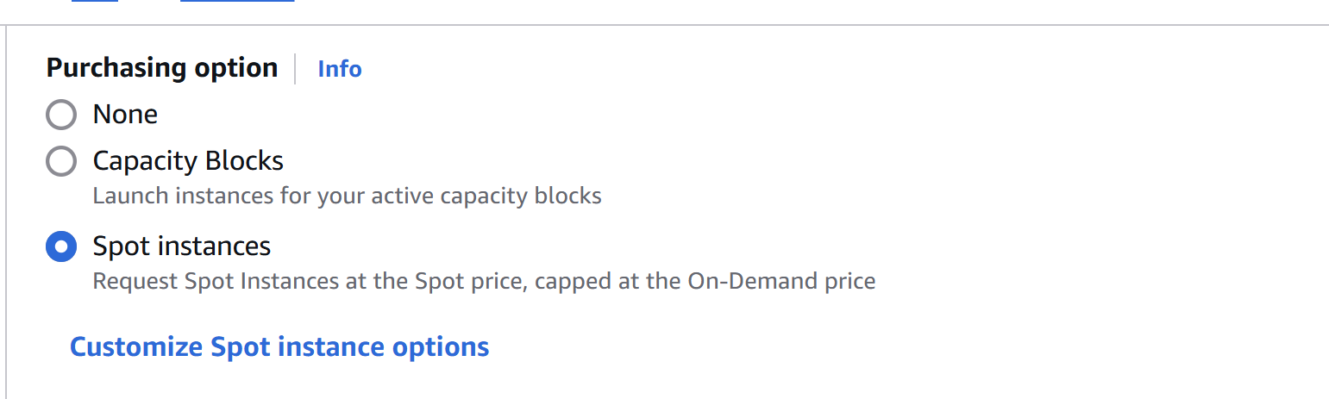

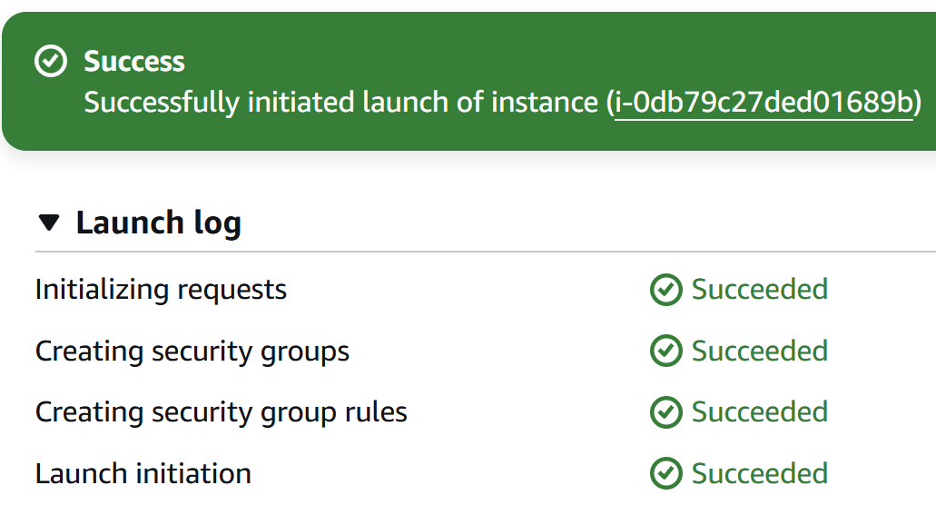

1. Enable Termination policy on ec2 created in Task 2.

* Select the instance
* Then  **Actions-🡪 Instance Settings 🡪 Change Termination Protection**
* Then **Enable and Save.**

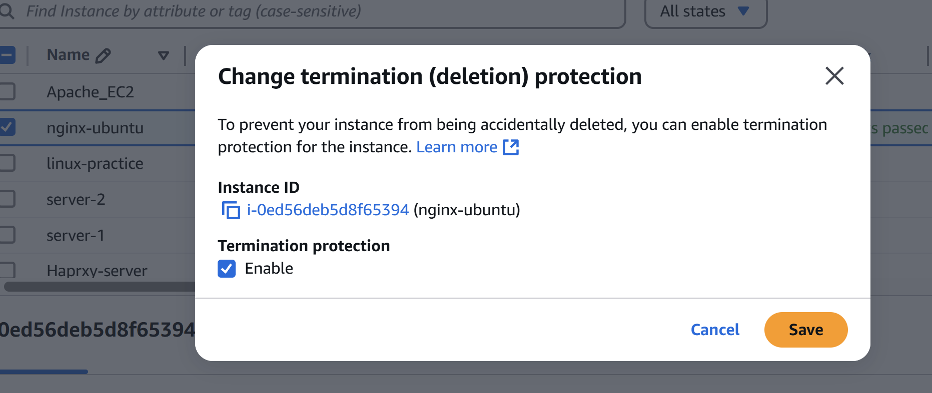

8) Launch one ec2 using Aws CLI.

* Download AWS CLI from their(windows) website and install

<https://docs.aws.amazon.com/cli/latest/userguide/getting-started-install.html>

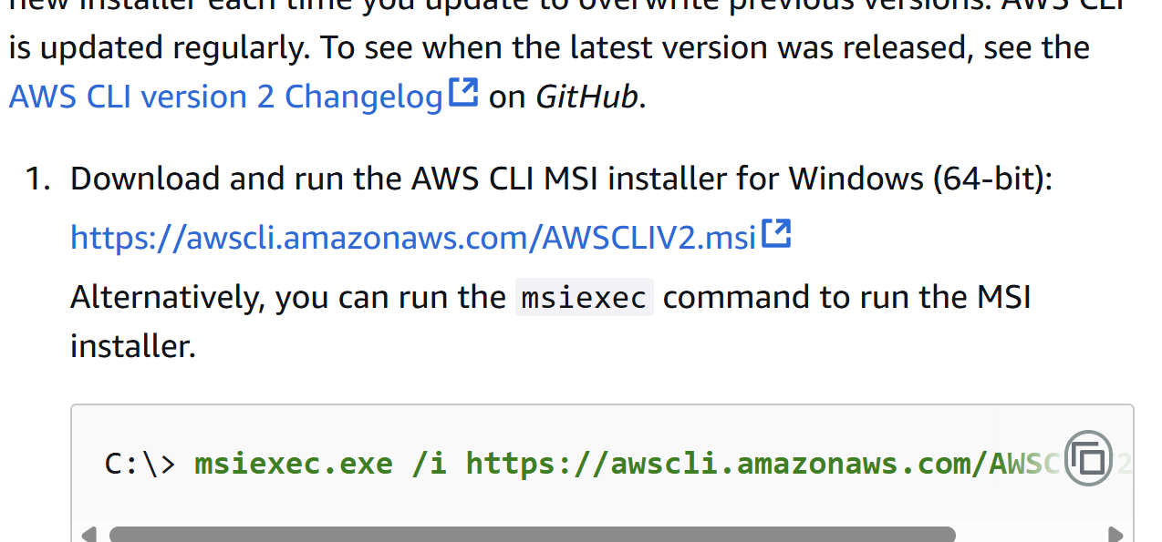

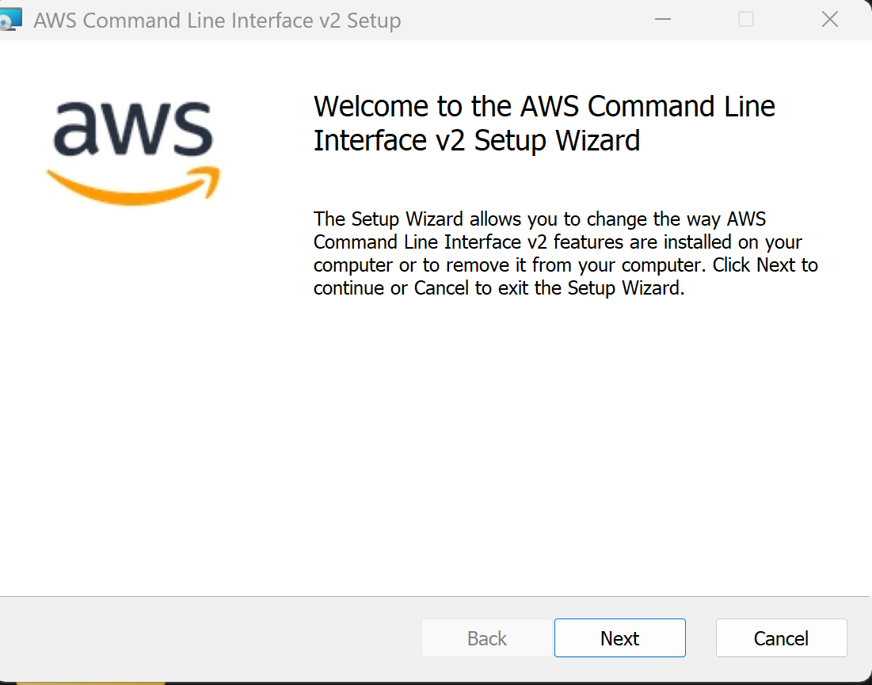

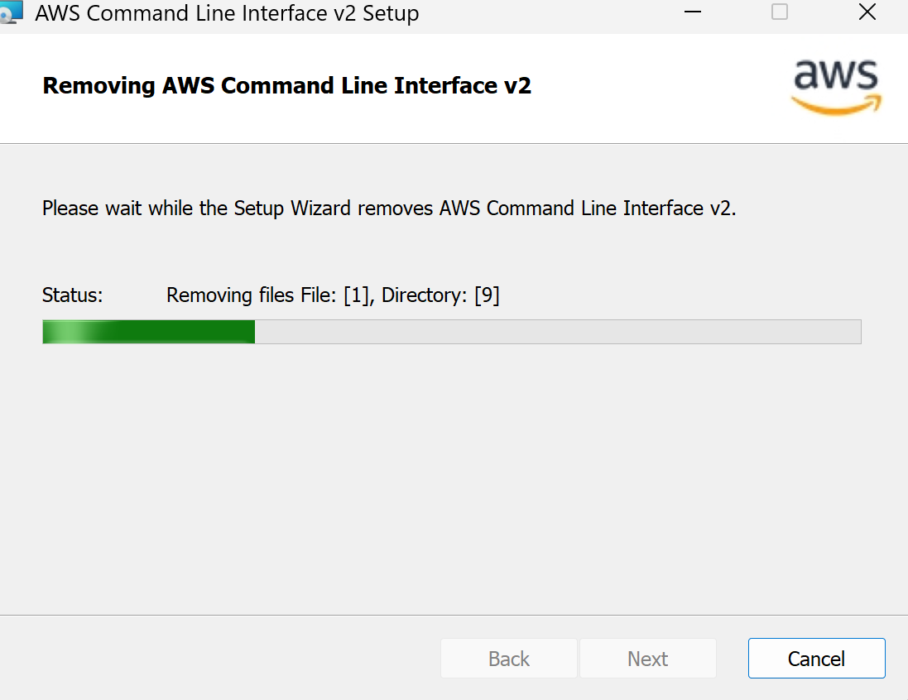

Go to AwS account and open account top Left side ->click on security credientials

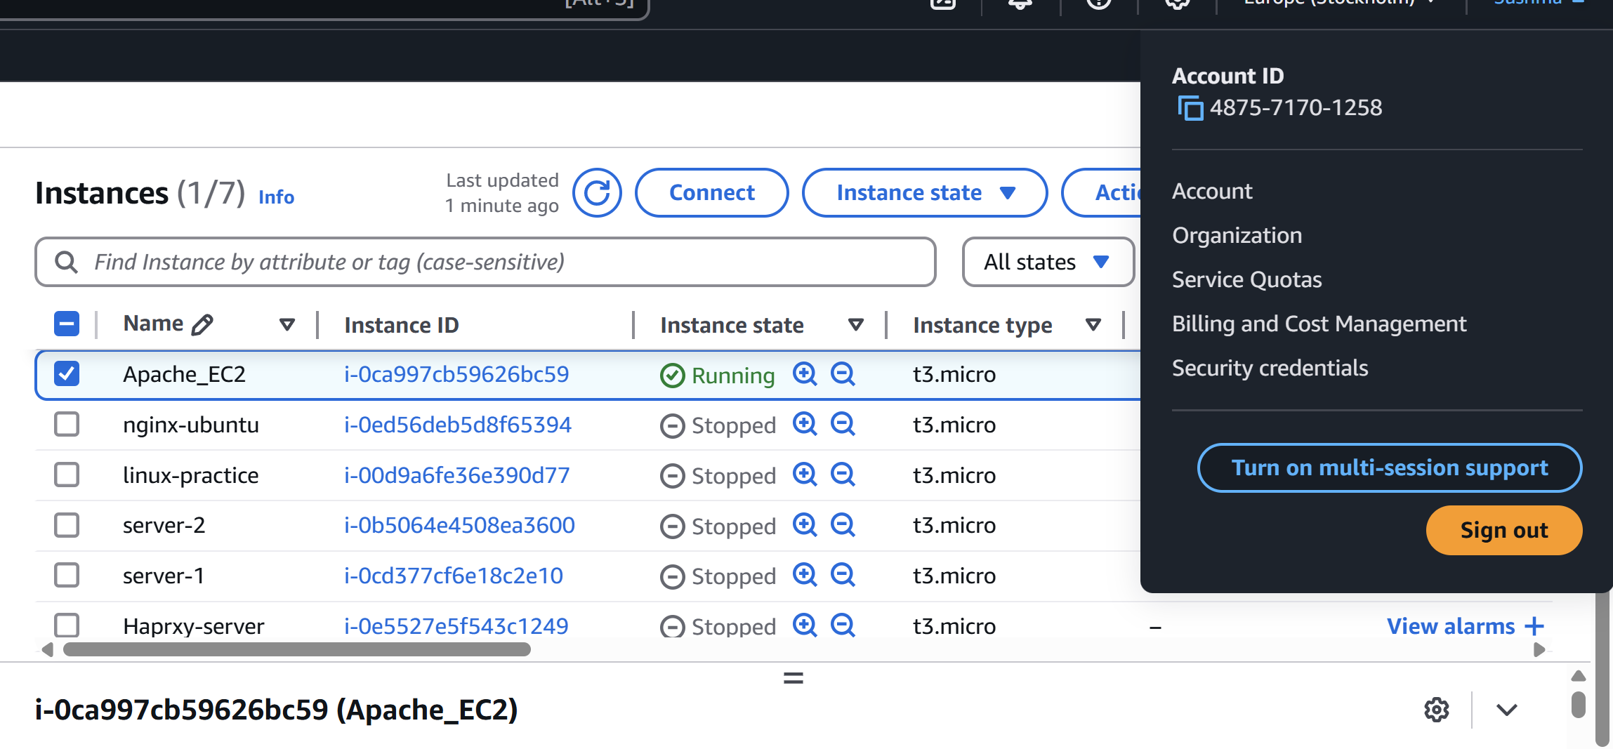

* Scroll down we can see access key click on create access key

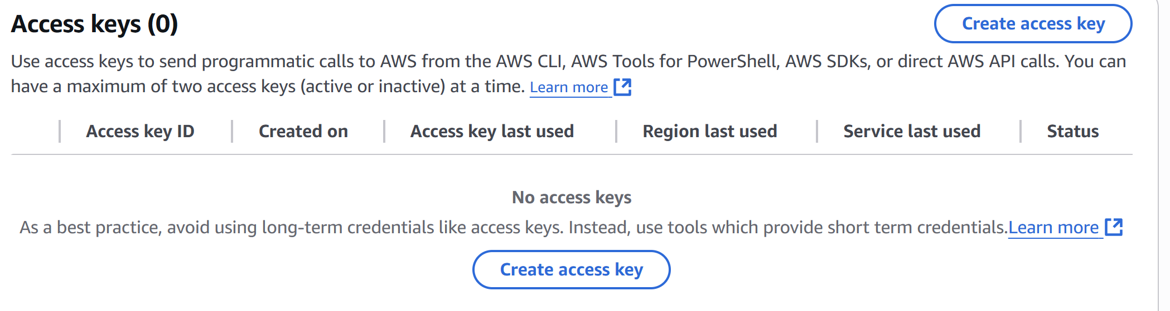

* Access key and Security access key is generated

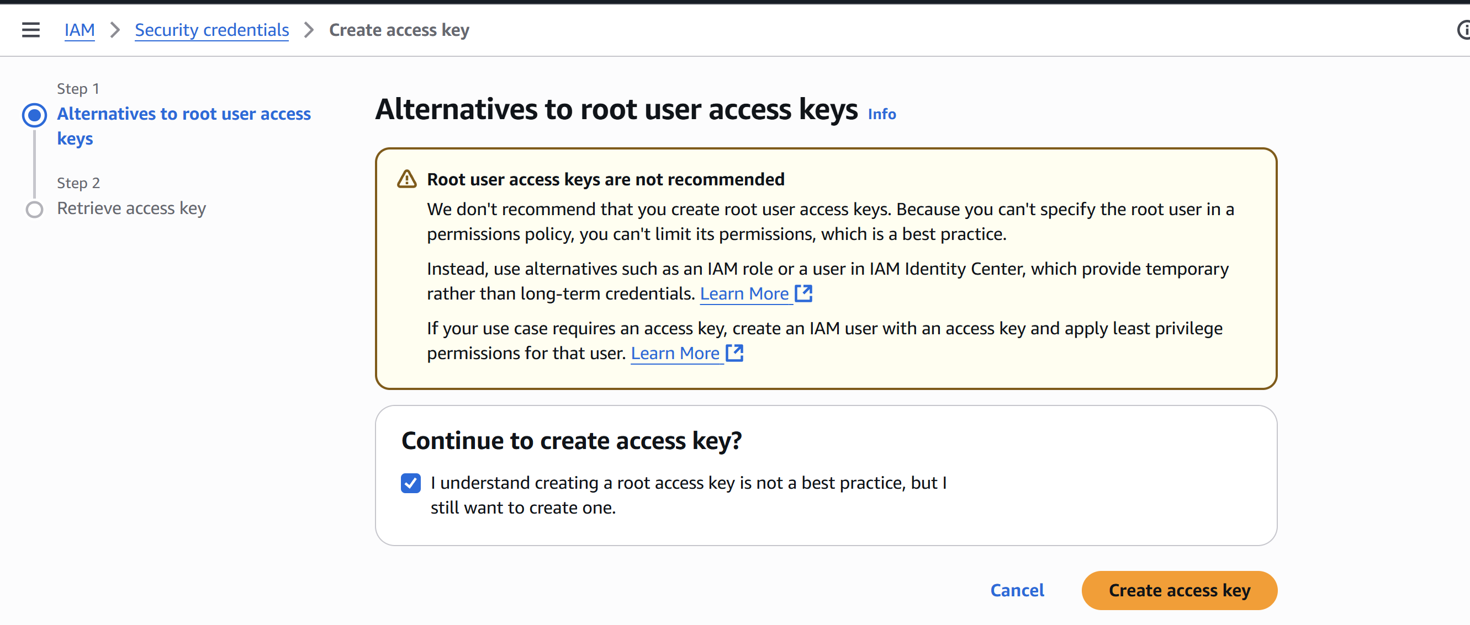

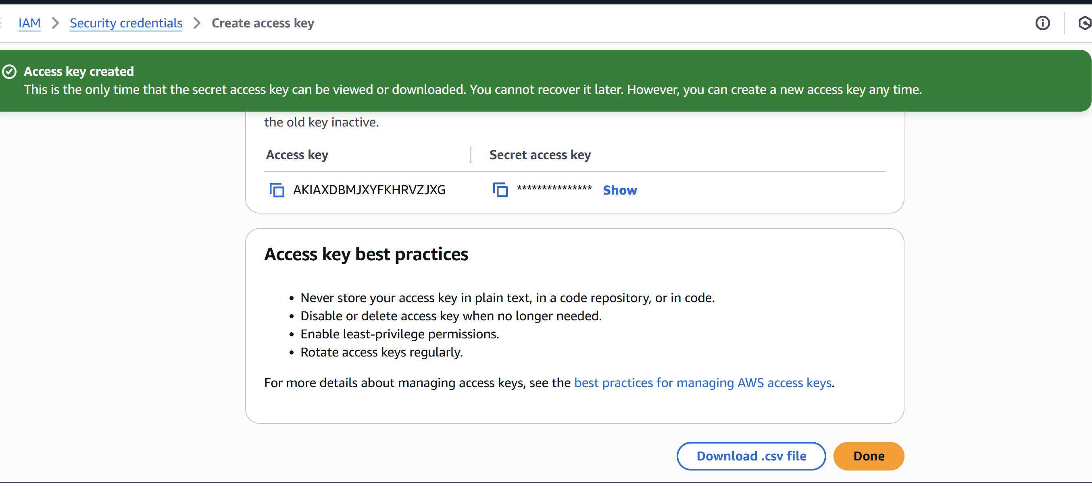

* Open Git bash type aws --version
* Aws configuration give access key and security access key

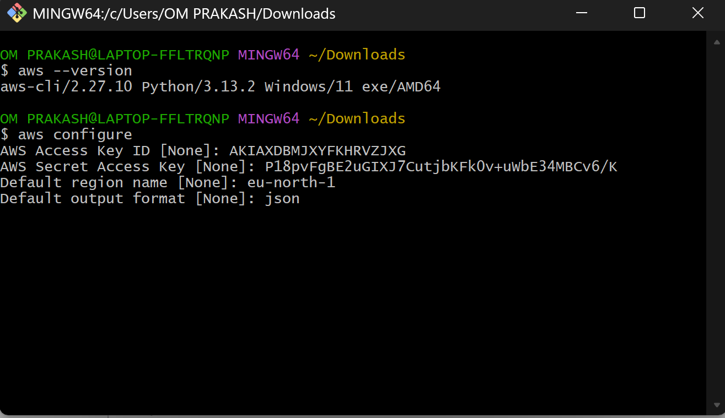

* aws ec2 run-instances command is used to **launch a new EC2 instance** — think of it as telling AWS, “Create a virtual machine with these specific settings.
* Get ami id,sg id and subnet id from ani of instance

aws ec2 run-instances \

--image-id ami-0dd574ef87b79ac6c \

--instance-type t3.micro \

--key-name Aws_key \

--security-group-ids sg-04eb2e744015d2bd4 \

--subnet-id subnet-0f671fe6027f057eb \

--count 1 \

--tag-specifications '[{"ResourceType":"instance","Tags":[{"Key":"Name","Value":" Apache_EC2 "}]}]'

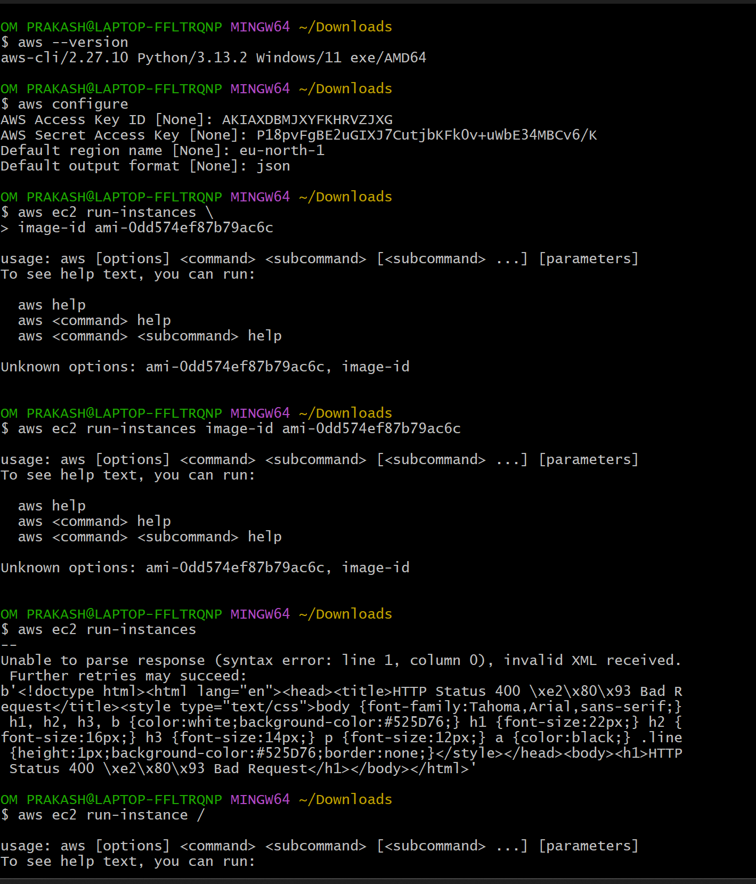

* If you want to get only the key pair names in a table format

aws ec2 describe-key-pairs --query 'KeyPairs[*].KeyName' --output table

* aws ec2 describe-instances \

--instance-ids i-0c56e79a1c1ffdbdc \

--query 'Reservations[*].Instances[*].PublicIpAddress' \

--output text

* chmod 400 K.pem
* Ssh -i <>pemkey ec2-user<ipaddress>

